 | Production CUBE |  | Quote request
 | 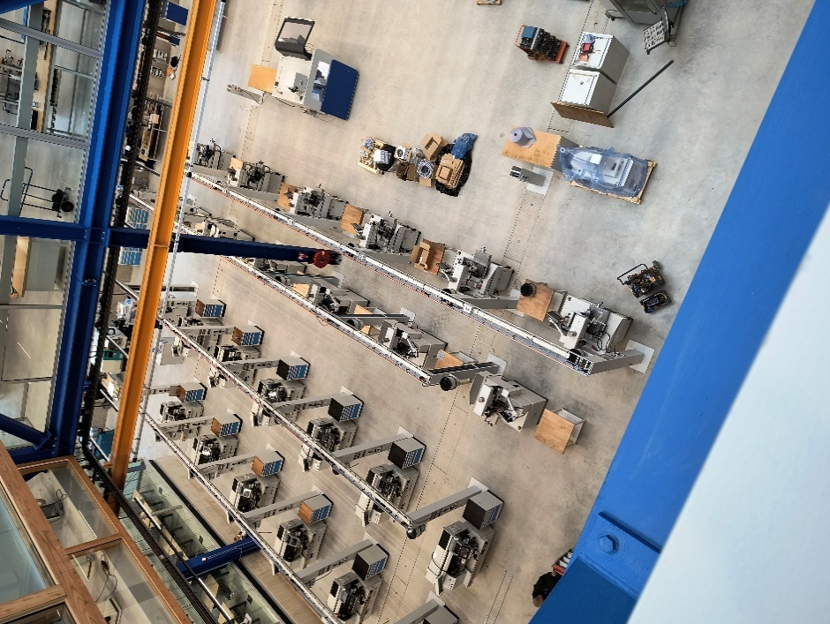
 |  |  | Company name:
 | ITEMS | DESCRIPTION | QUANTITY | TOTAL
 | CB30E | PP wheel 30 mm | 8000 | €0,00
 |  |  |  | €0,00
 |  |  |  | €0,00
 |  |  |  | €0,00
 |  |  |  | €0,00
 |  |  |  | €0,00
 |  |  |  | €0,00
 |  | SUB TOTAL |  | €0,00
 |  | VAT 21% |  | €0,00
 |  | SHIPPING |  | €500,00
 |  | GRAND TOTAL |  | €0,00
 | INSTRUCTIONS:
 | Once signed, mail it to sales@production-cube.com
 | NAME | SIGNATURE | DATE
 |  | THANK YOU FOR YOUR BUSINESS!
 | Should you have any enquiries concerning your order, contact sales
 |  |  | E-mail: sales@production-cube.com
 |  |  | Web: www.production-cube.com

